pXRF analysis

Uine Kailamäki

04/01/2021

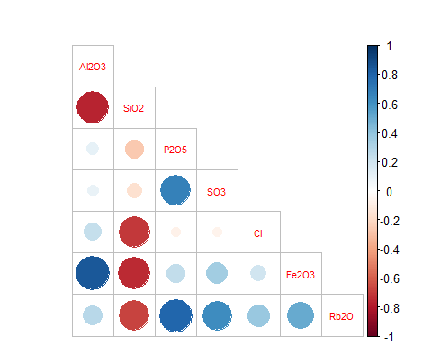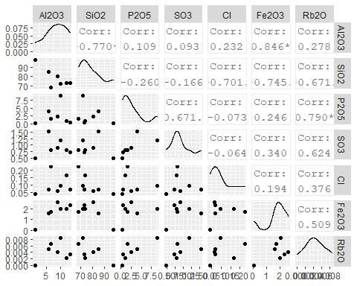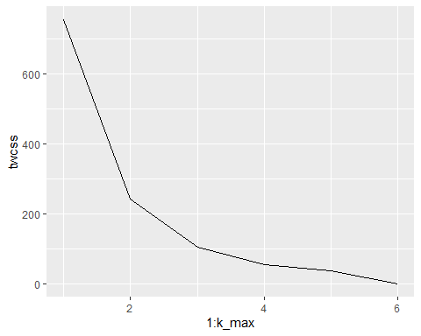

## Importance of components:  
## PC1 PC2 PC3 PC4 PC5 PC6 PC7  
## Standard deviation 10.53 3.00093 2.42646 0.42695 0.21352 0.02324 1.413e-18  
## Proportion of Variance 0.88 0.07148 0.04673 0.00145 0.00036 0.00000 0.000e+00  
## Cumulative Proportion 0.88 0.95145 0.99819 0.99963 1.00000 1.00000 1.000e+00

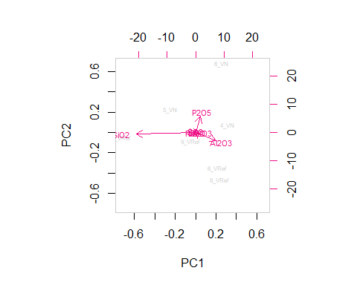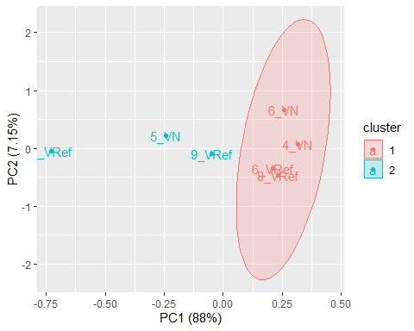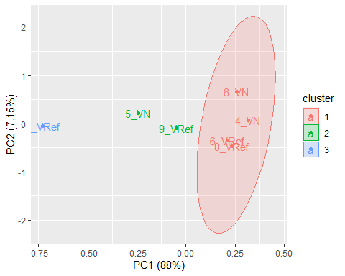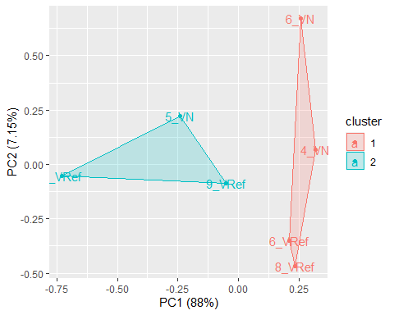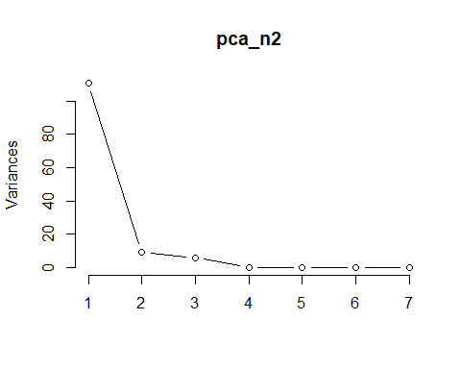

## [1] 0.7028222

